CURRICULUM VITAE (edited)

BRANDI ANDRADE
603 Davis St. #2010
Austin, TX 78701
214-566-0462 (cell)
drbandrade@gmail.com

Current Employment: 1990-Present. Professional Theatre and Broadcast Artist, now based in
Austin Texas. Actor, Director, Dramaturg, Children’s Theatre, Voiceovers. Represented
by Linda McAlister Talent Agency in Waxahachie, Texas.
Education
Doctor of Philosophy Humanities-Aesthetic Studies. Univ. of Texas at Dallas.
Fall 2004. Concentrations in American Women’s History and Feminist Theatre.
Dissertation: Hedda and Her Sisters: Realism, Feminism, and Social Reform
On the American Stage.

Master of Arts, Humanities-Aesthetic Studies, Univ. of Texas at Dallas. Fall 1998.

Bachelor of Science in Drama-Television-Film with high honors, Oral Roberts Univ.
Spring 1992.
Professional Certification

Accent and Dialect Intensive with Elly Lindsay, Arts Magnet. Summer 2013.
Voice and Diction Intensive with Gregory Lush, KD Actor’s Conservatory. Summer 2013.
Advanced Acting Seminar with Jerry Russell, Stage West. Fall 2012.
Film Audition Workshop, Dan Millican, Serendipitous Films. Fall 2010.
Readers Theatre Institute, Seminar in London, England. Summer 1999.
Acting Seminar with Tina Parker. Dallas Theatre Center. Spring 2004.
Audition Workshop with Casting Director Donise Hardy and actor Pato Hoffman.
CastingWorks LA. Dallas. Spring 2006

Select Teaching and Administration

2010-2016. Full-time Senior Lecturer, Theatre Arts Program, University of Texas
at Arlington. In addition to all work done as Adjunct, also professor of additional
courses in the department. Developed new Dramaturgy Course as a Practicum area for all Theatre Arts Majors, helping students identify research areas for all Mainstage shows and produce support materials for each show on social media platforms, as well as program and website essays, and lobby displays. Developed Core Curriculum material for Introduction to the Theatre and Theatre Appreciation courses and created the syllabi now used by all instructors of the course, syllabi that served as university-wide models as the Core Curriculum was adopted across campus. Mentor to a group of Theatre Arts Majors, meeting with them every semester before academic advisement. Director of theatrical productions produced by the Theatre Arts Department. Collaborator on three student-directed productions of THE VAGINA MONOLOGUES, 2012-2014, put on by
Women’s Studies and Multi-Cultural Affairs. Attended and supported department
activities, including campus productions, faculty meetings, recruitment events, and
continuing support of students outside classroom.

2014-2016. Affiliated Faculty in the Women’s and Gender Studies Department.
Developed two gender-based theatre courses that were added to the University
Catalogue. Taught one per semester, cross-listed in both the Theatre and the Women’s
and Gender Studies departments. Attended and supported activities in this department.
Maintained affiliation through outside activities demonstrating interest in the field.

2010 – 2015. Artistic Associate, Echo Theatre, Dallas, Texas. Assisted with all aspects
of production, from set-building to mailing of printed material, including creation and execution of fundraising ideas. Directed one staged reading per year, and performed in
an annual holiday fundraiser.

2002-2010. Adjunct Faculty, Theatre Arts Program, University of Texas at Arlington.
Professor of the Introduction to the Theatre courses. Developed and taught new general
Arts course, Theatre and Film Appreciation. This course now serves as the department’s
main arts course for non-majors, with an enrollment of 100 students per semester per section. Professor of Acting For Majors courses, including developing course material.

2008-2010. Faculty member, Acting Program, KD Actor’s Conservatory. Professor of
Script Analysis courses, including developing course material, meeting with students.

2004-2010. Producing Partner at Echo Theatre, Dallas Texas.
Served as chief Dramaturg for the theatre, assisting in the selection of plays, biographical
and historical research for individual plays, writing program essays, and moderating post-
show talkbacks. Responsible for maintaining relationship with Echo 100s, a select group of financial backers. Served from 2005 - 2007 as the Artistic Director of the popular staged reading series that gives voice to important women playwrights of the past and present. Served as lead producer on acclaimed production of String of Pearls in 2007. Served as co-producer of staged reading of Oil! Starring Tyne Daly in 2008. Assisted in marketing, box office, outreach, selection of artists and designers for each production, and day-to-day operations.
Conference Presentations
Women’s Equality Day Celebrations 2006-2009, 2015 and 2017. Curated presentations of 19th- and 20th-century woman suffrage material, performed at the Dallas City Hall, sponsored by the Women’s Issues Network. Producer, Director, Editor, Actor

“Speech by Susan B. Anthony,” performed as Susan B. Anthony at the 10th, 11th, and 13th Annual Susan B. Anthony Award Luncheons, sponsored by the Dallas Chapter of the
League of Women Voters. February, 2006 and February, 2007. Emcee and Hostess,
February, 2009. Editor, Performer.

How the Vote Was Won by Cicely Hamilton and Christopher St. John, performed at
the Women’s Equality Day Celebration at the Women’s Museum: An Institute for the
Future. August, 2006. Producer, Director, Actor.

“Scenes from Edit Villarreal’s My Visits with MGM,” performed at the International Women’s Day Celebration at the Women’s Museum, March 2005. Producer.

“The Daughters of the Late Colonel: a theatrical reading and adaptation of
Katherine Mansfield’s short story,” performed at “Arts & Letters Live” at the Dallas
Museum of Art, April 2004. Producer, Adapter, Performer.

“The Yellow Wall-Paper,” a dramatic presentation of Charlotte Perkins Gilman’s short
story, performed at the 6th Annual United Nations North Texas Chapter Conference on
Women at the University of Texas at Dallas, November, 2002. Solo Performance.

“Voicings: A Celebration of American Women,” presented at the 9th Annual Wilma
E. Grote Symposium for the Advancement of Women at Moorehead State University,
Moorehead, Kentucky, March 2000. Producer, Author, Performer.
“Trifles: A Readers Theatre version of Glaspell’s play,” a feature presentation at the
2nd Annual United Nations North Texas Chapter Conference on Women at the University
of Texas at Dallas, November 10, 1998. Performer.

“Opening Ceremonies Theatrical Presentation” at the 1st Annual United Nations
North Texas Chapter Conference on Women at the University of Texas at Dallas,
November 15, 1997. Creator, Performer.

Select Publications

“Touching Greatness,” published by Theatre Jones website in conjunction with Theatre Three’s production of William Inge’s Picnic in Oct. 2015. (Mark Lowry, editor of Theatre Jones.) http://www.theaterjones.com/ntx/features/20151029110844/2015-10-29/Touching-Greatness

“Paula Vogel’s American Ghosts,” published as a program essay and on the Theatre Three website in conjunction with a production of Vogel’s A Civil War Christmas in Nov. – Dec. 2014.

“Ronnie Claire and Her Very Human Curiosities,” published as a program essay and on the Theatre Three website in conjunction with a production of Ronnie Claire Edwards’ Candy Barr’s Last Dance in Aug. 2014.

“Lynn Nottage’s Introductions,” published as a program essay and on the Theatre Three website in conjunction with a production of Nottage’s By the Way, Meet Vera Stark in June-July 2014.

“The ‘Tornado’ as Pragmatic Idealist and Pioneer,” essay on Margo Jones, published on the Margo Jones website in conjunction with the release of the film, “Sweet Tornado: Margo Jones and the American Theatre.” April, 2006. <http://www.sweettornado.org/resources/andrade.lasso>

Select Theatre Experience - Acting

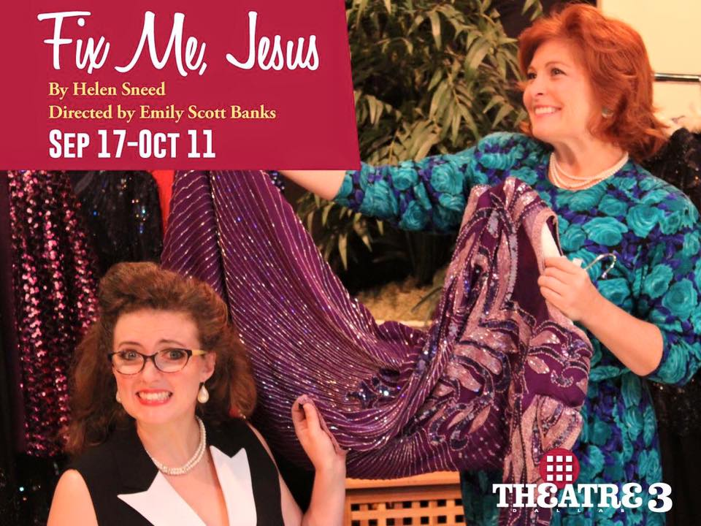 Mrs. Craig in Fix Me, Jesus at Theatre Three, Sept. – Oct. 2015. “[Andrade’s] performance is so even and natural that it can almost get lost in the hysteria created by the other characters. But if a “best actress” award was given for this show, her name would be on it with all the others. They are all first among equals here.” Fort Worth Star-Telegram

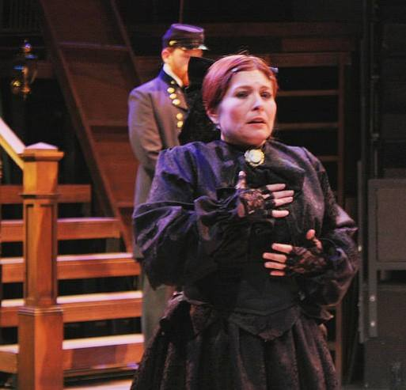 Mary Todd Lincoln in A Civil War Christmas at Theatre Three, Nov. – Dec., 2014. “In [a] stunningly sung scene, Andrade’s Mary Todd Lincoln visits a dying Union soldier…giving the sense that the love with which she offers her song translates in his mind into the words he longs to hear.” Nancy Churnin, Dallas Morning News

Pamela Peabody in The Fox on the Fairway at Onstage in Bedford in April 2014. “The Fox on the Fairway at ONSTAGE in Bedford was absolutely fantastic…Brandi Andrade gave a wonderful performance.” Eric Maskell, THE COLUMN

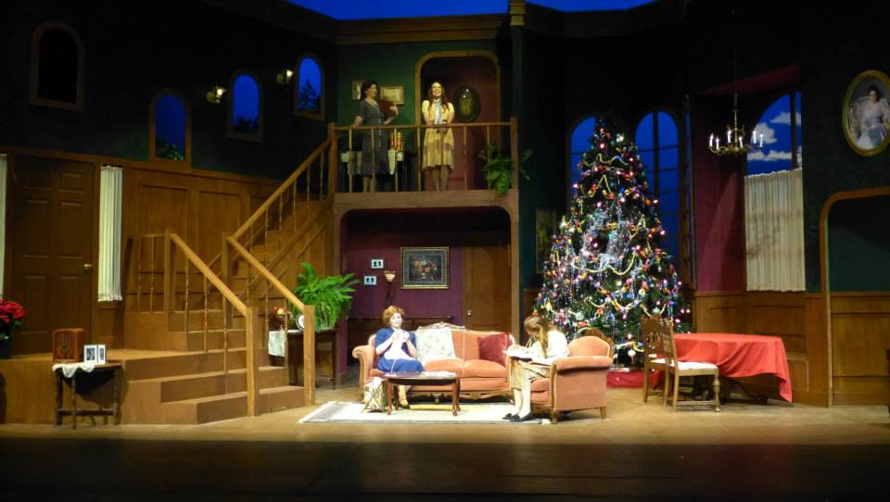 Reba in Last Night of Ballyhoo at ICT Mainstage in May-June, 2013. “Andrade…plays Reba Freitag…perfectly…[H]er presentation just shines onstage.” Richard Blake, Examiner

Lee in Tale of the Allergist’s Wife at Theatre Arlington in Jan. 2013. “Top Ten of 2013.” “Solidly acted by a tight cast…Andrade [is] a sexy tornado.” Arnold Wayne Jones, Dallas Voice. “As Lee, Andrade is funny and free-spirited.” Mark Lowry, Theatre Jones.
Select Theatre Experience – Directing

Calendar Girls Summer 2016, Theatre Arlington
(awarded “Best Play” and “Best Director” of Theatre Arlington’s 2015-2016 season)
Trifles MavPlays Festival, Spring 2015, UT Arlington
After the Revolution Staged Reading, 2013, Echo Theatre
Holy Days Studio Theatre Season, 2012, UT Arlington
Tragedy: A Tragedy Mainstage Theatre Season, 2010, UT Arlington
Overtones Theatrefest 2010, UT Arlington
Overtones Festival of Independent Theatres, 2009, Echo Theatre;
A Lie of the Mind Asst. Director, Mainstage Theatre Season, 2009, UT Arlington
Almost Maine Asst. Dir., KD Actor’s Conservatory, Spring 2009

